

**THE PRIMARY PLANET RESOURCE PACK**

**March 2023**

**ISSUE #120**

**TEACHERS**

**www.newsmagmedia.ie**

**CHILDREN**

**www.theprimaryplanet.ie**

**Copyright © News Mag Media Limited 2023. All rights reserved. If you or your school is not a paid subscriber, neither the whole of this publication nor any part of it may be reproduced, photocopied, stored in a retrieval system or transmitted in any form or by any means without the written permission of the publishers News Mag Media. To subscribe, or for more information, email** [**stephen@newsmagmedia.ie**](mailto:stephen@newsmagmedia.ie)

**THE PRIMARY PLANET RESOURCE PACK**

**The Writing Corner**

**March Short Story Theme:**

**An Unexpected Guest**

In this month’s Writing Corner, we have chosen the theme of ‘an unexpected guest’. Perhaps he or she was human, perhaps not. Maybe it was a good visit, maybe not. Fiction, non-fiction, we don’t mind. Any thoughts?

**Top tips on writing by bestselling author Helena Duggan**

1. When you’re first sitting down to write your story, forget about beautiful sentences or elaborate words – just write it as it comes. Allow the story to flow from your head onto the page without judgement and see where it takes you. Let your imagination free.
2. Don’t reread the full story until you’ve gotten to the end, otherwise you might never finish. You see, if you’re like me (and 99% of the population), when you go back over what you’ve written you may think it’s terrible and you might give up. So don’t do it. Wait until the story is finished and then go back with a clear head.
3. Everybody’s first attempt is terrible, that’s why it takes a million attempts to write a book. That’s where editing comes in. I’ll let you in on a secret – at first, I hated editing. I had to teach myself to appreciate it which eventually grew to liking it … ‘ish’. But editing is what brings your story together – it polishes the plotlines and makes the words sing.
4. Believe in yourself. Stop doubting. You can do it and you are good. Remember what you are writing is your world and so it can be anything you want it to be. Stop worrying about what anyone else thinks and just enjoy the story.
5. Never give up! If I was to give only one piece of advice, that would be it. It’s simple, if you never give up you’ll write that story, or climb that mountain, or do whatever it is you want to do. Too many people convince themselves they can’t and so they don’t. Tell yourself you can – and you will!

**Keep your stories and poems to around 400 words**

**Deadline: February 22**

**Email your entries to** **schools@theprimaryplanet.ie**

**Include a title, along with your name and school details**

**Published writers receive a cool TPP hoodie!**

**THE PRIMARY PLANET RESOURCE PACK**

**Weekly TPP Mental Maths Challenge**

Join us online every Monday morning (www.theprimaryplanet.ie) for your weekly Mental Maths Challenge. You have from Monday to Thursday to complete the 15 mental maths questions we set.

Log on to the website on the Friday morning for the answers ... and to listen to TPPer requests and shout-outs. You can email those to schools@theprimaryplanet.ie

|  |  |
| --- | --- |
|  |  |
|  |  |
|  |  |
|  |  |
|  |  |
|  |  |
|  |  |
|  |

**Weekly Quiz Answer Sheet**

Every week, one lucky TPP reader wins themselves a TPP hoodie!

**THE PRIMARY PLANET RESOURCE PACK**

**TPP Quiz of the Week**

Join us online every Monday morning (www.theprimaryplanet.ie) for your weekly TPP Quiz. You have from Monday to Thursday to complete the 15 fun questions we set.

Log on to the website on the Friday morning for the answers ... and to listen to TPPer requests and shout-outs. You can email those to schools@theprimaryplanet.ie

|  |  |
| --- | --- |
|  |  |
|  |  |
|  |  |
|  |  |
|  |  |
|  |  |
|  |  |
|  |

**Weekly Quiz Answer Sheet**

Every week, one lucky TPP reader wins themselves a TPP hoodie!

**Sample Questions:**

**Rishi Sunak got fined for not wearing his seat belt. Who is he?**

**What is the world’s tallest dog breed?**

**Hurls are made from the wood of which tree?**

**Listen to this audio clip and name the singer or the song.**

**THE PRIMARY PLANET RESOURCE PACK**

**Vocabulary Constabulary**

**Are you a good detective? The Vocabulary Constabulary needs your help.**

You can often detect the meaning of a word or phrase by reading it in context, that is, by reading the other words around it in a piece of text. Find the page, article or paragraph in TPP and then detect the word or phrase that solves the clue to its meaning. The number of letters and the starting letter of the solution are in brackets after each clue.

**LOCATION, Article/Paragraph** **CLUE (number of letters, first letter)**

1. P3 The dark side understand; comprehend; get (5,g)
2. P3 Addiction worry; concern; uneasiness (7,a)
3. P6 Oldest … Dog animals kept on a farm (9,l)
4. P6 Search and Rescue pieces of broken bricks or stone (6,r)
5. P7 … Nazca Desert remarkable; impressive (11,o)
6. P7 … Plastic those who do something wrong; offenders (8,c)
7. P8 Béal na Bláth a group of vehicles or ships travelling together(6,c)
8. P8 New leadership [serious](https://www.collinsdictionary.com/dictionary/english/serious) bleeding [inside](https://www.collinsdictionary.com/dictionary/english/inside) a person's body (11,h)
9. P9 51 years ago! beings from beyond Earth’s atmosphere (17,e)
10. P9 26 years ago! Dangerous to your health or safety (9,h)

 **Your answers In alphabetical order**

**THE PRIMARY PLANET RESOURCE PACK**

**Vocabulary Constabulary**

**Are you a good detective? The Vocabulary Constabulary needs your help.**

You can often detect the meaning of a word or phrase by reading it in context, that is, by reading the other words around it in a piece of text. Find the page, article or paragraph in TPP and then detect the word or phrase that solves the clue to its meaning. The number of letters and the starting letter of the solution are in brackets after each clue.

**LOCATION, Article/Paragraph** **CLUE (number of letters, first letter)**

1. P9 Engineers Week organised people and things involved an event (11,c)
2. P10 … Deadliest Killer? almost; nearly (11,p)
3. P10 POTA-TOE show the exact position of something (8,p)
4. P10 … The Hay! [recessed](https://www.collinsdictionary.com/dictionary/english/recess) [compartment](https://www.collinsdictionary.com/dictionary/english/compartment) in front of the seats of a vehicle (8,f)
5. P10 On Target person who twists their body into [unnatural](https://www.collinsdictionary.com/dictionary/english/unnatural) positions (13,c)
6. P15 Planet Art [shallow](https://www.collinsdictionary.com/dictionary/english/shallow) [hole](https://www.collinsdictionary.com/dictionary/english/hole)s or cuts in the [surface](https://www.collinsdictionary.com/dictionary/english/surface) of something (12,i)
7. P19 The climb the top of a mountain (6,s)
8. P26 Who are they to … motivate; stimulate (7,i)
9. P27 3 Be willing … developed in [personality](https://www.collinsdictionary.com/dictionary/english/personality) and [emotional](https://www.collinsdictionary.com/dictionary/english/emotional)ly (8,m)
10. P28 … Kites (paragraph 2) a city with over 10 [million](https://www.collinsdictionary.com/dictionary/english/million) inhabitants (8,m)

 **Your answers In alphabetical order**

**THE PRIMARY PLANET RESOURCE PACK**

**Vocabulary Constabulary**

**Are you a good detective? The Vocabulary Constabulary needs your help.**

You can often detect the meaning of a word or phrase by reading it in context, that is, by reading the other words around it in a piece of text. Find the page, article or paragraph in TPP and then detect the word or phrase that solves the clue to its meaning. The number of letters and the starting letter of the solution are in brackets after each clue.

**LOCATION, Article/Paragraph** **CLUE (number of letters, first letter)**

1. P28 … Kites (paragraph 3) crippled; mutilated; disabled (6,m)
2. P28 … Kites (paragraph 10) belief in things that are not [real](https://www.collinsdictionary.com/dictionary/english/real) or [possible](https://www.collinsdictionary.com/dictionary/english/possible) (12,s)
3. P29 Taylor’s … [corroborate](https://www.collinsdictionary.com/dictionary/english/corroborate)d; verified (9,c)
4. P29 Chiefs Win … to defeat by a small amount (3,p)
5. P29 Irish Record-Breakers convinced that something will happen (9,c)
6. P29 … Mercedes changed; altered; converted (11,t)
7. P31 Tough Start … great sadness and emotional suffering; pain (9,h)
8. P31 Tough Start …  [hopeful](https://www.collinsdictionary.com/dictionary/english/hopeful) about the [future](https://www.collinsdictionary.com/dictionary/english/future) or the [success](https://www.collinsdictionary.com/dictionary/english/success) of something (10,o)
9. P4 Ukraine … offered to do something without being forced (11,v)
10. P28 More amazing … [flourishing](https://www.collinsdictionary.com/dictionary/english/flourishing); [successful](https://www.collinsdictionary.com/dictionary/english/successful); doing very well (7,b)



 **Your answers In alphabetical order**

**THE PRIMARY PLANET RESOURCE PACK**

**Edit the Editor**

**Read through the article from this month’s magazine and see if you can spot the 10 spelling mistakes.**

**Teddy Bear Hospital (Page 4)**

Hundreds of young schoolkids turned up at Univercity College Cork recently to get medickal treatment for their furry best friends. Medical students heeled broken bones and performed life-saving operations in minutes. In one week, more than 750 children, aged 4 to 6, visited the ‘hospital’.

The experiense helps young kids deal with anxiaty around real hospital appointments, by letting them learn about medicine and meet doctors in a fun setting. The teddys get treated with X-rays and vaccines, and that prepares the kids for getting such treatments themselves.

It’s also great for the medical students because most first- and second-years don’t get hostipal experience until their third year. It’s good practice for them to interact with people … and, eh, actual patience …

The kids came up with no end of crazy make-believe alements and accidents: falls from roofs of houses, freak trampeline accidents – most imaginative perhaps was Piggy the pig being pricked with a pin while rolling in mud.

Dressing up in kid-size doctors’ gear, face-painting and goody bags were the icing on the cake and, despite the shocking injuries, a good time was had by all!

 **Misspelt word Correct Spelling**

**THE PRIMARY PLANET RESOURCE PACK**

**Edit the Editor**

**Read through the article from this month’s magazine and see if you can spot the 10 spelling mistakes.**

**Outstanding Success (Page 5)**

What a proud moment for us Irish when Martin McDonagh axcepted the BAFTA award for *The Banshees of Inisherin* as Outstanding British Film! And this after he had alredy won Best Original Screenplay, Barry Keoghan had won Best Supporting Actor and Kerry Condon Best Suporting Actress.

But, hold on a minute there, I hear you say … *Best What?* Outstanding *British* film? But … it was Irish,was’nt it? Filmed on ilands off our west coast,with an all-Irish cast, written and directed by aman called McDonagh! It couldn’t be *more* Irish, could it?

Let me explain … allthough I had to Google it first … The nationality of a film depends on who the producers were and who has paid for it to be made. *The Banshees* was funded by British companys and one US one. Two of the producers are British – and the third, Martin McDonagh himself, was born and bread in London though his parents were Irish. Yes, the Banshees is tecknically British. Though its heart is truly Irish.

Barry Keoghan and Kerry Condon warmed hearts with their acceptance speeches. Barry dedicated his BAFTA to ‘the kids that are dreaming to be something from the aerea that I came from’. And Kerry thanked her horses and dogs. Enough said!

**Misspelt word Correct Spelling**

This activity can be completed online at www.theprimaryplanet.ie ©News Mag Media 2021

**THE PRIMARY PLANET RESOURCE PACK**

**Edit the Editor**

**Read through the article from this month’s magazine and see if you can spot the 10 spelling mistakes.**

**Honda Going Green (Page 6)**

The Japaneese car company Honda has announced a new vehicle coming out next year that will be powered by a hydrogen fuel sell. This is great news for the enviroment! Hydrogen gives off no harmful emisions into the air. The company is working along with US General Motors. The cells will be made in Ohio and then sent to other locations in North America and in Japan.

Honda has been working on this alternatife to diesel engines or various hybrid systems since 1998. Recent efficincy improvements will lower the price of the vehicles and make them even faster to charge.

But Honda has set its sites beyond cars. They hope that this new tecknology will also be used in construction equipment, trucks, power for buildings, and even for use in travel to outer space! That’s certainly keeping an eye on the future.

Many other companies are following Honda’s example. Various types of electric and fuel cell vehicles are in the works. In addition, they continue to work on hybrid systems that make use of a combonation of green technology and the more old-fashioned petrel or gas engines.

 **Misspelt word Correct Spelling**

**THE PRIMARY PLANET RESOURCE PACK**

**Cloze Test**

**Read through the words in the Word Bank first and make sure you understand them. Then, read the article. Make sure you think about the best place to put a word, not the first place. Careful as you go, as some words may fit in more than one place, while other words will only suit one.**

**Kerry**

County Kerry, Contae Chiarraí, is in the Southwest of Ireland in the ________ (1) of Munster. Kerry is a ________ (2) county bordered by Cork and Limerick with the Shannon ________ (3) to the north and the Atlantic Ocean to the west. It is a mountainous county with wonderful scenery and the Lakes of Killarney, often called “Heaven’s reflection” are world-famous for their ________ (4).

sheep

beauty

everyone

province

explorer

sites

Estuary

major

million

maritime

Kerry is Ireland’s premier tourist destination with around two ________ (5) visitors each year. There is something for ________ (6) in “The Kingdom”: breath-taking views, fishing, water sports, golf, hill-climbing, music and historic ________ (7). However, one of the county’s greatest assets remains its friendly people.

Agriculture is of ________ (8) importance with many dairy farms supplying the major international food processing company, the Kerry Group PLC. There is a large number of ________ (9) in the county also.

Famous Kerry people include “The Liberator” Daniel O’Connell, ________ (10) Tom Crean, writer Peig Sayers, playwright John B Keane, Sr. Stanislaus Kennedy who has devoted her life to helping the poor, and poet Brendan Kennelly.

**THE PRIMARY PLANET RESOURCE PACK**

**Cloze Test**

**Read through the words in the Word Bank first and make sure you understand them. Then, read the article. Make sure you think about the best place to put a word, not the first place. Careful as you go, as some words may fit in more than one place, while other words will only suit one.**

**The Speed of Light**

How fast does light travel? Scientists have known for over a hundred years that light always travels at the ________ (1) speed: 299,792,458 metres per second. Because it is always the same, it is called a constant.

The speed of light is the ________ (2) speed that all energy, matter and information in the ________ (3) can travel at. If you could travel at the speed of light, you could go around the Earth 7.5 times in one second.

**Word Bank**

visible

include

galaxy

fastest

invisible

remember

short

same

universe

slowed

To understand light, you have to know that what we call light counts for all things ________ (4) to humans. Animals, on the other hand, can see different types of light. For example, dogs can see only shades of grey, while some insects can see light from the ultraviolet part of the spectrum which is ________ (5) to us. The key thing to ________ (6) is that our light is what scientists call ‘visible light’.

Visible light is only one small part of a family of waves called electromagnetic radiation. These waves ________ (7) radio waves, which have very long wavelengths and both gamma rays and cosmic rays, which have very ________ (8) wavelengths. Visible light is near the middle of the spectrum.

It takes about seven minutes for light from the sun to reach Earth, and over four years to get to the nearest star. It would take a particle of light over 100,000 years to get from one side of our ________ (9) to the other side.

All of those times measure light moving through a vacuum. Light is ________ (10) down as it passes through other substances such as the atmosphere, water, or a diamond. Light moves at about 124,000,000 metres per second through a diamond.

**THE PRIMARY PLANET RESOURCE PACK**

**Cloze Test**

**Read through the words in the Word Bank first and make sure you understand them. Then, read the article. Make sure you think about the best place to put a word, not the first place. Careful as you go, as some words may fit in more than one place, while other words will only suit one.**

**Paintbox Hillside**

In Lima, the capital of Peru, ________ (1) worked for at least nine months in 2022 to create a ________ (2) mural on a hillside. The project involved using bright jewel tones to paint the ________ (3) of over 1,000 homes on the side of San Cristobal Hill.

**Word Bank**

government

plan

jobs

gigantic

completed

designers

live

ancient

remote

exteriors

The rainbow-coloured hillside, based on ________ (4) patterns, can now be clearly seen from miles around. A local art group called Energy Color came up with the ________ (5). In the past few years, many people in Peru have moved from ________ (6) areas into Lima. Most of them had been leaving their new homes plain brown and grey.

The ________ (7) in Lima paid for the new paintwork, which was ________ (8) by a private company. The goal was to bring a positive feeling into a somewhat dangerous neighbourhood.

Completion of Project Rainbow created many new ________ (9), and hopefully the pretty results will also offer a long-lasting sense of togetherness to those who ________ (10) in the area.

**THE PRIMARY PLANET RESOURCE PACK**

**Quiz-32**

**This month's 32-quiz is based on the 32 pages of TPP, E.g. The answer to Q.7 can be found on page 7.**

1. On what date is World Wildlife Day 2023?

2. On what page will you find Planet Farming?

3. What type of balloon was K9YO?

4. What is the Latin word for church?

5. In what county is the town of Granard?

6. This Labrador Retriever was a famous search and rescue dog.

7. In what country is the Nazca Desert?

8. Who succeeded Michael Collins as Commander-in-Chief of the National Army?

9. In what year was the first official St Patrick’s Day Parade in New York?

10. What are the ‘fingers’ on a star-nosed mole’s nose called?

11. What is Lord Carnaby’s profession?

12. Bruce McLaren was a native of this country.

13. In what county is Killala?

14. ________ is using electronic devices to hurt, upset or intimidate a person.

15. Trompe l’oeil is French for ______ the eye.

16. What is the more common name for the binturong?

17. On which continent is Guinea?

18. What is another name for a bristletail?

19. In what year was the first officially recorded climb of The Rock of Guatapé?

20. What number goes in the top, left square in the Futoshiki Puzzle?

21. What is the solution to 13 DOWN in the crossword?

22. The Space Mirror Memorial is made from this type of rock.

23. The first animal to orbit Earth was called ________.

24. Who is the author of the Alex Rider book series?

25. In what county is Athlone?

26. Your role models should always be celebrities – true or false?

27. ‘*Sometimes all you need is twenty seconds of insane ______.’*

28. What is synthetic thread coated in ground-up glass or metal called?

29. Patrick ______ is the quarterback for the Kansas City Chiefs.

30. Whose Tottenham Hotspur’s goalscoring record did Harry Kane break?

31. Jarlath Burns is from this county.

32. On what date will *Mummies* open in Irish cinemas?

**THE PRIMARY PLANET RESOURCE PACK**

**Word Search**

**All the words in the word search can be found in this month’s Feature ‘The Misnomers of Nature’.**

**There are 20 words listed below. Can you find them?**



**THE PRIMARY PLANET RESOURCE PACK**

**Sudoku**

**Each of the 9 boxes must contain the numbers 1 – 9. When you ﬁll them in, you will then see that each line going across and each line going down also contains the numbers 1 – 9.**

**Easy**

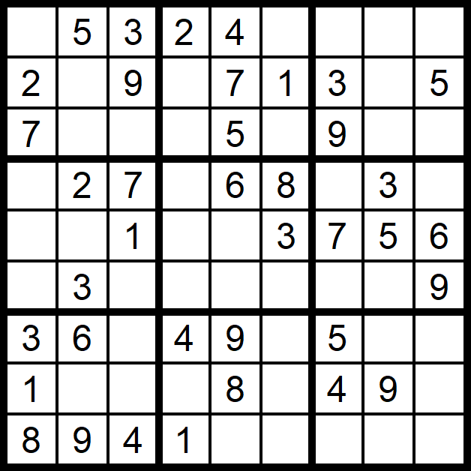

**Hard**

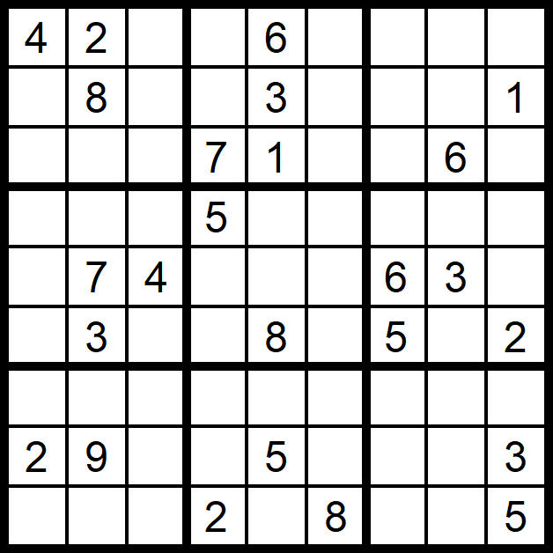

**THE PRIMARY PLANET RESOURCE PACK**

**Crack the Quote**

**In this month's Crack the Quote, an inspiring quote or message is waiting to be cracked. When you solve it, see if you can come up with an illustration that you think captures the essence and meaning of those words.**

**THE PRIMARY PLANET RESOURCE PACK**

**Come Dine with Me**

**This month’s issue, as always, is packed full of inspirational stories about amazing people. Imagine you were going to host a fancy dinner party. Which two people would you choose from this month’s issue (dead or alive) to join you at your table? We would like a brief explanation of your choices and three questions that you would ask them to get the conversation flowing!**

|  |
| --- |
| **Name of Guest One:** |
| **Reason:** |
| **Questions you’d ask:** |

|  |
| --- |
| **Name of Guest Two:** |
| **Reason:** |
| **Questions you’d ask:** |

**THE PRIMARY PLANET RESOURCE PACK**

**Drama Time**

**Each month, we invite you and your class to base your drama lesson on a theme from The Primary Planet.**

**This month, we are turning our attention to the news section, both national and world news, as a starting point. We challenge you to create a short piece of drama, involving an array of characters, to demonstrate one of the news stories covered. To help you, should you need it, we have provided some ideas below.**

|  |
| --- |
| Idea 1: Create a comedy drama around the topic of misnomers in nature. Have a pet shop as your setting and see if you can create scenes where lines of communication are getting mixed because of the inaccuracies of certain animal names in nature. |
| Idea 2: Create a drama based on a TV talk show, where some positive role models and some negative role models are questioned on certain topics. |
| Idea 3: Imagine that you work in the shop (or the ice cream stand) at the summit of El Peñón de Guatapé. Take your audience through your day, including how you get to work and back home again (all those stairs!) as well as the people that you meet and chat to throughout the day. |
| Idea 4: Prepare and present a short drama piece on cyberbullying. Create two alternative endings – a best-case and a worst-case scenario. |
| Idea 5: Create a TV report on the Balloon fiasco in the US. As part of the report a number of people are interviewed for their opinion on the whole affair. Think about the dialogue you can create for this. |

**THE PRIMARY PLANET RESOURCE PACK**

**Let’s Talk**

**Based on articles from this month's mag, we want you to think about some of the issues that arise. Remember, when you are trying to put forward an opinion, or an argument, make sure you know your facts and figures and be clear in how you feel about a certain topic and why. Here are some questions and statements you and your class might like to consider thinking about and discussing. Some you will agree with, some you clearly won't!**

|  |
| --- |
| My favourite book of all time is ……. because ……. |
| Turtles are better than chameleons. |
| Balloons should be illegal. |
| All couture is junk. |
| Cyberbullying isn’t real bullying. |
| One of my role models is ________ because ________ |
| Kites (that humans fly) should be banned. |
| Amanda Serrano’s injury is fake. She just doesn’t want to have to fight Katie Taylor in Ireland. |
| Pets are a waste of time and money. |
| Is it ever OK to steal? |
| Batman would beat Superman, hands down. |
| School uniforms should be banned. |

**THE PRIMARY PLANET RESOURCE PACK**

**Save the Kites from the Kites**

Awareness can be a major force for good. Very often people discover they were unaware of a problem that they would otherwise have been happy to try and help solve. For this activity, create a poster, poem or work of art to help spread awareness of the problems the kite birds of prey are facing..

|  |
| --- |
| Did You Know?  *Portrait of a woman of the Hofer Family* is a most unusual and interesting painting. It differs from other portraits because there is a fly perched on the woman’s hat – a very lifelike fly at that! We don’t know the identity of the artist, but it was painted in Germany around 1470 and now hangs at the National Gallery, London. |
| Did You Know? |
| Did You Know? |
| Did You Know? |
| Did You Know? |

**THE PRIMARY PLANET RESOURCE PACK**

**Did You Know?**

**Every issue of your *Primary Planet* is packed full of facts and ﬁgures. Why not record the top 4 things that you learned from this issue. When you do, make sure to create an illustration to go with each one. When you are ﬁnished, share and discuss your choices with your classmates. We have added our favourite one below. You’ll see I didn’t just copy it from *TPP*, I wrote it out in my own words. Always a great idea when doing a project.**

**THE PRIMARY PLANET RESOURCE PACK**

**Deich gCeist**

**Tá siad simplí agus tá na freagraí le fáil in *The Primary Planet* na míosa seo.**

1. Tá sé ina bhainisteoir ar foireann peile Mhaigh Eo.
2. Príomhchathair na hIndia.
3. Tháinig Alexander Fleming ar an **antaibheathach** seo in 1928.
4. Cá bhfuil an **leacht cuimhneacháin** *The Fallen Astronaut*?
5. Cen cineál ainmhí é an mountain chicken?
6. **Maraíodh** Michael Collins anseo.
7. An t-údar a scríobh an leabhar *Run With the Wind*?
8. Cén tír ina bhfuil an Fásach Nazca?
9. **Stiúir** sé an scannán *The Banshees of Inisherin.*
10. Bhris Israel ______ an churiarracht náisiúnta 60m faoi dhíon an mhí seo caite.

**Foclóir**

**antaibheathach** – antibiotic

**leacht cuimhneacháin** – monument

**Maraíodh** – was killed

**Stiúir** – directed

**THE PRIMARY PLANET RESOURCE PACK**

**What’s in the News?**

**How well have you read *The Primary Planet* this month? Here, in ‘What’s in the News’, as well as testing your memory and retention skills, we also test your imagination and creative skills. This activity is based on our National and International news sections. Read the articles and answer the following questions.**

1. Read the article ‘Teddy Bear Hospital’. Do you think it’s a good idea? Why do you think so?

2. Read the article ‘World’s Oldest Living Dog’. What is your favourite dog breed? Give reasons for your answer.

3. Read the article ‘Ukraine Photojournalist’. Write some advantages and some disadvantages (in your opinion) of working as a photojournalist.

4. Read the article ‘Ancient Art in the Nazca Desert’. Use your research skills to find and record (in your own words) ten facts you learned from this article.

5. Read the article ‘Outstanding Success’. What is your favourite film? Give reasons why you chose it.

6. Read the article ‘Junk Kouture’. Rewrite this article in around fifty words.

7. Read the article ‘Cork Enterprise’. Make a list of ten questions you would like to ask the Church brothers.

8. Read the article ‘Honda Going Green’. Design a poster to encourage people to protect the environment.

9. Read the article ‘Search and Rescue’. Use your research skills to find and record ten facts about earthquakes.

10. What was your favourite news story in this month’s TPP? Why?

**THE PRIMARY PLANET RESOURCE PACK**

**Know Your Sport**

**How well have you read this month's sports news? Here, in Know Your Sport, we’re testing your memory and retention skills. We’ve based this crossword on the pages from our sports section. Can you complete it?**



**Across**

**2** Denise Gaule plays this sport (7)

**4** Superbowl champions 2023 ______ City Chiefs (6)

**6** The 2023 F1 season begins here (7)

7 Rhasidat ______ holds the Irish 400m women's indoor record (7)

**11** Steve Borthwick is the head coach of this country's rugby team (7)

**15** The 2023 National Indoor Athletics Championships were held here (10)

**16** This famous horse racing festival begins on March 14 (10)

**19** Harry Kane's dad came from here (9)

**Down**

**1** Madison Square ______ is a sport's arena in New York (6)

**3** Lewis Hamilton drives for them (8)

**5** Alan ______ has scored the most goals in the Premier League (7)

**8** Ireland play Scotland in rugby in this city on March 12 (9)

**9** Newly elected as president of the GAA - ______ Burns (7)

**10** Irish record holder in the indoor 60m sprint event (8)

**12** American football team - ______ Eagles (12)

**13** Ireland's opponents in the Women's Six Nations on April 1 (6)

**14** Dr Hyde Park is in this county (9)

**17** They play the Republic of Ireland at the Aviva Stadium on March 22 (6)

**18** Jarlath Burns played Gaelic football for this county (6)

**ANSWERS #120**

**Vocabulary Constabulary**

|  |  |  |
| --- | --- | --- |
| 1. grasp  2. anxiety  3. livestock  4. rubble  5. outstanding  6. culprits  7. convoy  8. haemorrhage  9. extraterrestrials  10. hazardous | 1. coordinated  2. practically  3. pinpoint  4. footwell  5. contortionist  6. indentations  7. summit  8. inspire  9. maturity  10. megacity | 1. maimed  2. superstition  3. confirmed  4. pip  5. confident  6. transformed  7. heartache  8. optimistic  9. volunteered  10. booming |

**Cloze Test**

|  |  |  |
| --- | --- | --- |
| 1. province 2. maritime 3. Estuary 4. beauty 5. million 6. everyone 7. sites 8. major 9. sheep 10. explorer | * 1. same   2. fastest   3. universe   4. visible   5. invisible   6. remember   7. include   8. short   9. galaxy   10. slowed | 1. designers  2. gigantic  3. exteriors  4. ancient  5. plan  6. remote  7. government  8. completed  9. jobs  10. live |

**Editing**

|  |  |  |
| --- | --- | --- |
| 1. University  2. medical  3. healed  4. experience  5. anxiety  6. teddies  7. hospital  8. patients  9. ailments  10. trampoline | 1. accepted  2. already  3. supporting  4. wasn’t  5. islands  6. although  7. companies  8. bred  9. technically  10. area | 1. Japanese  2. cell  3. environment  4. emissions  5. alternative  6. efficiency  7. sights  8. technology  9. combination  10. petrol |

**Deich gCeist**

|  |  |  |  |  |
| --- | --- | --- | --- | --- |
| 1. **Kevin McStay** | 1. **New Delhi** | 1. **peinicillin** | 1. **ar an ngealach** | 1. **frog** |
| 1. **Béal na Bláth** | 1. **Tom McCaughren** | 1. **Peiriú** | 1. **Martin McDonagh** | 1. **Olatunde** |

**Quiz-32**

|  |  |  |  |
| --- | --- | --- | --- |
| 1. **March 3** | 1. **13** | 1. **pico** | 1. **ecclesia** |
| 1. **Longford** | 1. **Frida** | 1. **Peru** | 1. **Richard Mulcahy** |
| 1. **1766** | 1. **rays** | 1. **archaeologist** | 1. **New Zealand** |
| 1. **Mayo** | 1. **cyberbullying** | 1. **deceive** | 1. **bearcat** |
| 1. **Africa** | 1. **silverfish** | 1. **1954** | 1. **2** |
| 1. **Glasnevin** | 1. **granite** | 1. **Laika** | 1. **Anthony Horowitz** |
| 1. **Westmeath** | 1. **False** | 1. **courage** | 1. **manja** |
| 1. **Mahomes** | 1. **Jimmy Greaves** | 1. **Armagh** | 1. **March 31** |

**Know Your Sport**

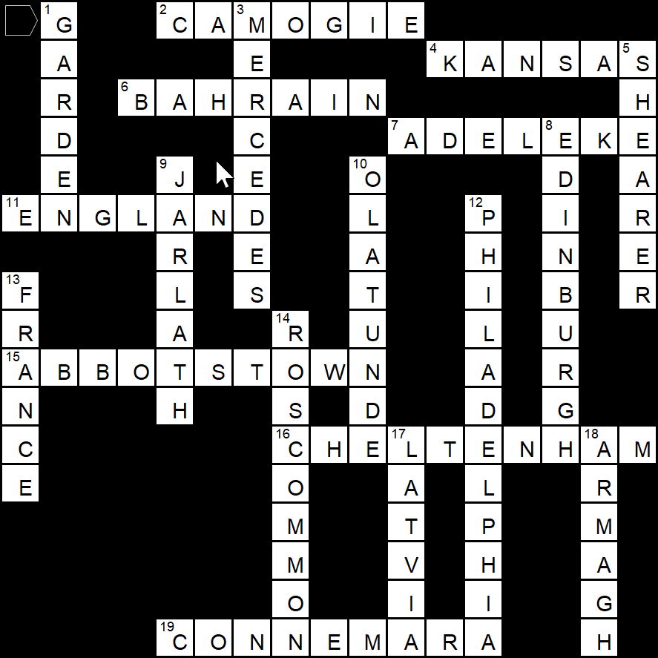

|  |
| --- |
| 1. How can you make notes out of stone? **Rearrange the letters**  2. What can you both eat and drink (and it’s not soup or anything like that)? **Toast**  3. What vegetable is dangerous in a boat? **A leek**  4. If Ireland should sink, what county would float? **Cork**  5. What is unusual about this word **SWIMS?** **It reads the exact same upside down.** |

**Go Figure**

|  |
| --- |
| 6 x 50 = 300 + (4 + 2) = 306 x 3 = 918 |

**Count Down**

**Sudoku (mag)**

**Futoshiki**

**Crack the Quote**

If you cannot speak good about someone, say nothing.

**Sudoku (Easy) Sudoku (Hard)**

**Maths Story**

1. I hr 32 mins
2. €130
3. 50
4. 185
5. 1,790
6. 56
7. €2.10

**Crossword**

**Word Search**

